|  |  |  |  |  |  |  |  |  |  |
| --- | --- | --- | --- | --- | --- | --- | --- | --- | --- |
| **e-Project Report** | | | | | | | | | |
| **Institute Name** | Aptech education | | | | **Curriculum** | | | 7062 | |
| **­**  **Batch** | 2301D | **Semester** | | | | | | | 1st |
| **Course** | DISM | **Faculty / Mentor** | | | | Sir Azhar Ghafoor | | | |
| **Assigned on** | 16th May, 2023 | | **End Date** | | | 17th June, 2023 | | | |
| **Submitted to** | Sir Azhar Ghafoor | | | **Submitted on** | | | 15th June, 2023 | | |
| **Project Name** | Seth Group of Companies Theme Park | | | | | | | | |
| **Subject** | Merciado Amusement Park Website | | | | | | | | |

**Presented by:**

**Syed Ibrahim Muhammad Hani Prem Kumar**

**Problem Statement**

Merciado Amusement park is now prime focus of the city and nation. It is made by Seth groups of companies. The development of this park took 5 years to get their desired finished product. It has became nation pride now. The area of theme park is about 45 acre land. The Management has put all the efforts to keep the attractions operational. The merciado management wants you to develop the website of the park which should include describing all the attraction of the park and also allow the user to book the ticket online.

**Requirement Specification:**

The Web site is to be created based on the following requirements.

1. The home page must be designed with beautiful color combination with all the required links defined properly. Also all the section of the webpage must be in used to avoid the blank space.
2. Different Zones and attraction, Restaurants, Entertainment, Tickets and Prices, Gallery be described in different webpage.
3. Prices value must be show the differences as per the day (like weekend or weekday or family pack).
4. About us, Contact Us, Disclaimer must be included.
5. Creating an account facility can also be added.
6. Dummy procedure for booking the ticket can be added.
7. Sitemap must be added.
8. Navigation of the project must be made smooth.

**Solution**

**Ticket Section:** The park has a base ticket price of just $49.99 but is hosting a family deal starting from 20th June, 2023. It offers a variety of deals and discounts which include meals, train rides and gaming zone which is called **THE MERCILESS ZONE**.

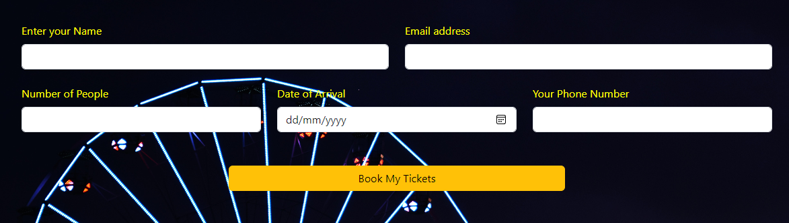**Design:** The website has a color palette of yellow and **black**. The form is there for the users to input their details and enter the date they are arriving on and submit button is to confirm the bookings for the day and their tickets will be reserved in the database.

Scrolling down we can see the cards that have a variety of deals for the families visiting the place. These cards have different hovers of different colors including but not limited to red, green and yellow. To ensure the smooth navigation, this transition takes 0.5s to transform into the colors which you can see. There is a small section of these colors in the corner of the cards indicating which color will their fill be on hovering.

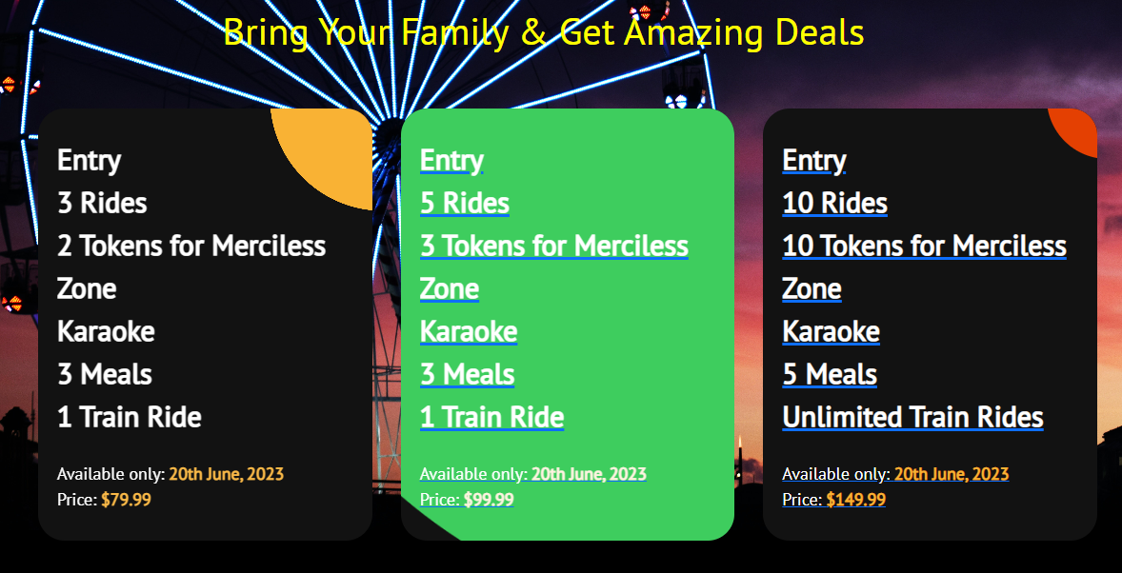

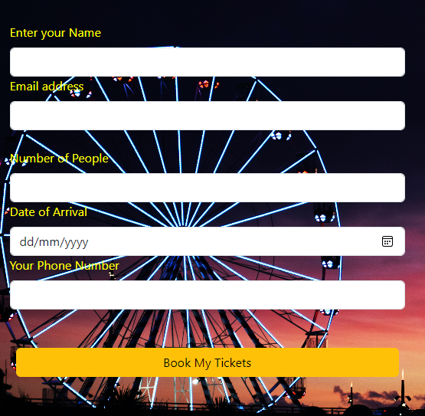The design is also made responsive by the usage of Bootstrap CSS framework.

It changes the view when minimized to at least 600px of width. The display of the div was made flexible using custom CSS and then the flex-direction has been changed to column in the media query section so that each of the form is line wise in the webpage.

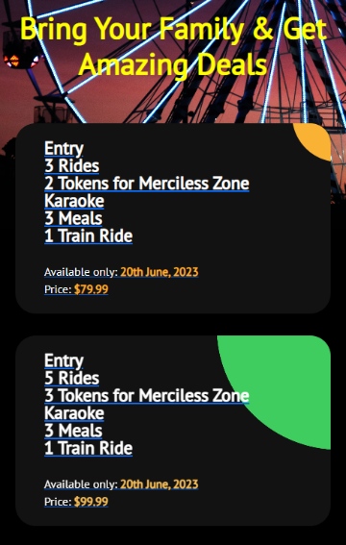

The same styling has been done to the discount section. The difference being the width of the cards. At first these were aligned next to each other and now beneath.

**Fonts:** PT Sans, Sans-Serif

**Colors:** #000, #fff, #f9b234, #e44002, #4c49ea

**Languages:** HTML, CSS

**Frameworks/Libraries:** Bootstrap & jQuery

**Sources:** GetBootstrap, Codepen